Instruction Manual
Lift&Tilt Scissor tables

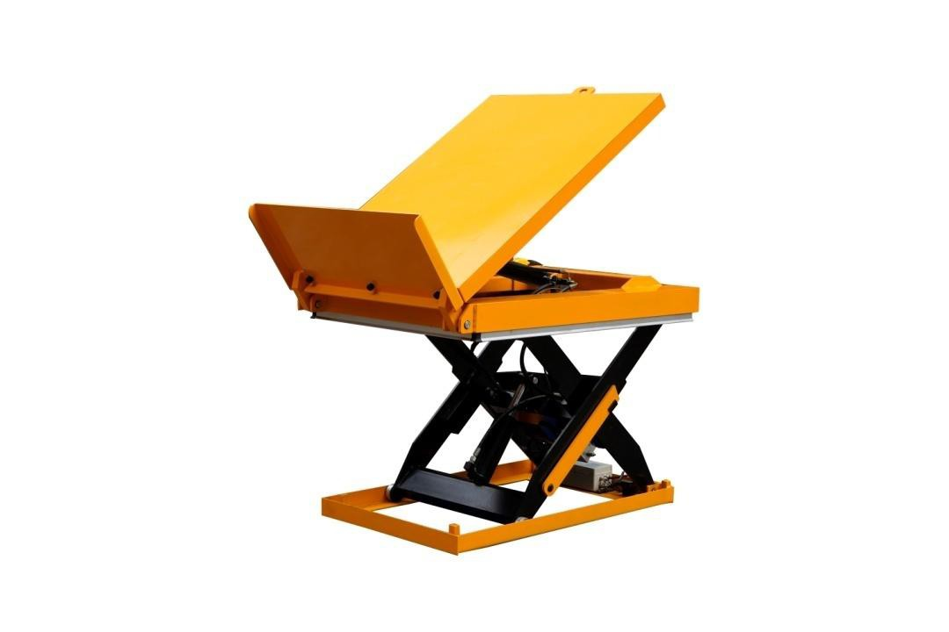

HWV1001

Note: Please do read carefully and understand completely this manual before the owner/operator uses the lift table.

THANK YOU VERY MUCH FOR SELECTING OUR PRODUCT.THIS INSTRUCTION MANUAL DESCRIBES CORRECT OPERATING METHOD TO ENSURE PROLONGED SERVICE LIFE.
PLEASE READ AND COMPLETELY UNDERSTAND THIS MANUAL BEFORE OPERATING THE LOW PROFILE LIFT TABLE. ALWAYS KEEP THIS MANUAL AT AN APPROPRIATE PLACE. IF THE MANUAL OR WARNING DECAL IS MISSING,
PLEASE CONTACT WITH DEALER.
Note:This Manual has been prepared for skilled and competent personal.It providesinstructionsforusingtheproductcorrectlyand parts list. This Manual cannot replace the professional skills and experimentation.

Brief Introduction
·The lift table has the function of electric lifting and lowering.
·With safety lifting switch, the operation is more efficient and convenient.
·It is mainly used for stacking or removing goods from the pallets.

Model |  | HWV1001
Capacity | (Kg) | 1000
Operation |  | Electric
Length | (mm) | 1300
Width | (mm) | 850
Max. Height | (mm) | 1200
Min. Height | (mm) | 305
No load rise time | (s) | 8
No load descent time | (s) | 7
Load rise time | (s) | 11
Load descent time | (s) | 9.5
Net weight | (kg) | 400

Explosive Drawing

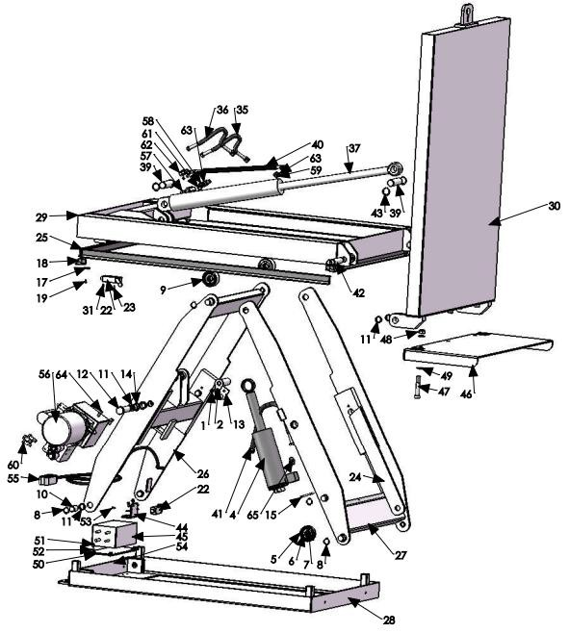
LIFT TABL ESPARE PARTS LISTW HWV1001

NO | DESCRIPTION | QTY | NO | DESCRIPTION | QTY
1 | M8×25 Allen socket bolt | 1 | 24 | Access frame | 3
2 | cylinder shaft | 1 | 25 | Safety aluminum strip | 2
4 | cylinder | 1 | 26 | inner scissors | 1
5 | Roller housing | 2 | 27 | outer scissors | 1
6 | 6205 Bearing | 6 | 28 | Base | 1
7 | Ø52 inner cir clip | 4 | 29 | Top Hand | 1
8 | Ø25 shaft cir clip | 18 | 30 | countertop | 1
9 | Upper roller housing | 2 | 31 | M4×12Phillips round head screw | 8
10 | scissor shaft | 4 | 35 | Oil tube 1200 | 1
11 | Ø28-Ø25-12 self-lubricating bearing | 12 | 36 | Oil tube 1300 | 1
12 | scissor bottom bracket | 2 | 37 | Tilt cylinder | 1
13 | scissor pivot axial stopper | 2 | 39 | Tilt cylinder shaft | 2
14 | Ø28-Ø25-21.5self-lubricating bearing with flinging | 4 | 40 | Oil tube 1 | 1
15 | φ5 cotter pin| | 1 | 41 | Oil tube 2 | 1
17 | Safety aluminum strip mounting gasket | 8 | 42 | axis of rotation | 2
18 | Corner Protector | 4 | 43 | Ø30 shaft cir clip | 4
19 | -M5×10 Hexagon Screw | 8 | 44 | Upper limit seat | 1
22 | YBLME 8104 Travel Switch | 5 | 45 | Control box | 1
23 | M4×25Phillips round head screw | 8 | 46 | Front baffle | 1

47 | Hexagon socket bolt M16×90 | 3 | 60 | G1/4articulated bolts/combination pads | 3
48 | M16 lock nut | 3 | 61 | Ø14 combination mat | 2
49 | ø16 flat pad | 6 | 62 | M14*1.5 one-way throttle valve | 1
50 | Control Box Mount | 1 | 63 | Ø10*1.9 O-ring | 4
51 | Hexagon M16×12 | 6 | 64 | M10*20 hexagon socket bolt | 4
52 | Remote Control | 6 | 65 | G3/8M18*1.5H connector | 1
53 | M5*14 phillips flat head screw | 4
54 | M4 Screw | 8
55 | Remote Control | 1
56 | Power Unit | 1
57 | M14*1.5 one-way throttle valve | 1
58 | M14*1.5 O-ring right angle joint | 1
59 | G3/8 bonded seal /M14*1.5 o-ring | 2

- Attention and Warning
·Use the lift table on flat and solid ground.
·Do not overload the lift table.
·Be sure the load is centered on the unit. If the goods are off center of gravity, they may slip. You may be hurt or the unit or load may be damaged.
·Do not move the lift table when it is loaded. This will damage the base frame of the unit.
It is necessary to check all parts work properly before adding load.

INSTALLATION OF LIFT T ABLE ON THEFLOOR/GROUND OR IN A PIT
Double or triple vertical scissors table smustbe fixed to the floor/ground
By means of ex pander bolt's similar，We also recommend that motherliness table types，with the exception of mobile units，are securely affixed on the floor prevent unintentional movement

Mechanical/electrical installation
- The baseframeofthelifttableisnotasstandardself-supporting. It is important that the flooring is flat and stable and that the installation area or pit, when necessary,is well drained.
- Utilize a lifting sling through the scissor package.Tie the base frame to the platform or the scissor mechanism.Locate the table into the desired position. Turn the fixed arm end to the side where the load will be moved on or off at upper level.See picture below.
- Check the operation of the safety frame on all sides.
- The control device should be positioned so that the operator has a clear view over the lift table and the load at all times when the lift is operated.


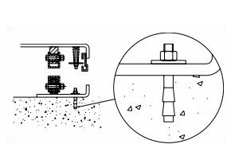

Loading/unloading at the fixed arm end Pit drawing
A.Pit length=a+30mmB.Pit width=b+30mmH.Pit depth=closed height of table+5mma.Platform length
- Platform width
- Drainage hole (when required)
- Tube for external cables and hoses φ60mmh.Lowest height
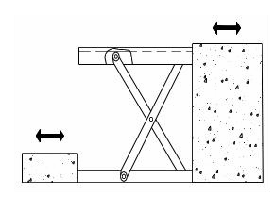

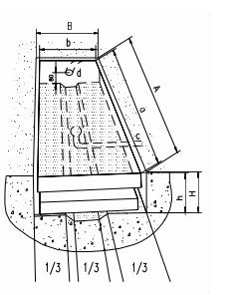

5. OPERATING THE LIFT TABLE
■LOADING
The maximum capacity of the lift tableis1000kg.Load should be distributed on the lift table equably.
■Lifting the Table
CAUTION!Do not overload the lift table.Ensure the balance of loading. Do not load partially or concentrically.

- Screw and loose emergency stop switch.
- PushtheUPbuttonandpowerpackstartstoworktolifttheload.
- Loose the UP button and power pack stops working.
■LOWERING THE TABLE

WARNING! Do not put foot or hand in scissors mechanism.
- Push the DOWN button and the table will lower.
- Loose the DOWN button and the table will stop.NOTE
- The table is equipped with an aluminum guard to avoid accidental danger.
- If aluminum guard strikes an object while the table lowers, stop operation and check the lift table. After making sure no any abnormality,strike the UP button slightly and then the electric
system will function as before.

Attention and Warning
·Use the lift table on flat and solid ground.
·Do not overload the lift table.
·Be sure the load is centered on the unit. If the goods are off center of gravity, they may slip. You may be hurt or the unit or load may be damaged.
·Do not move the lift table when it is loaded. This will damage the base frame of the unit.
·It is necessary to check all parts work properly before adding load.
■EMERGENCY STOP
There are two methods of emergency stop as follows.
◇Pushdowntheemergencystopswitchandthemovementoftable stops.
◇Strike aluminum guard upward and the movement of table also stops.
■TRANSPORTATION
If necessary,thelifttablecanbetransportedwithattachedringbolts.
◇Payattentiontothemaximumcapacityofliftingequipmenttobeused.
◇Keep the ring bolts with reasonableness.
■MOTOR WORKING TIME
◇Motor hours of work in one hour less than nine minutes.

SERVICE INSTRUCTIONS

■Do routine check of fasteners,packing and oil leaking.
■Do routine check of the function of the lift table.
■Before service the lift table, make sure to turnoff the AC power supply.
■Afterserviceitisnecessarytocheckthefunctionofthelifttable again.
■ONLY a qualified personnel can do service work.
■Do routine check of the micro-switches on the safety guard.
■Do routine check of the hydraulic system by listening its noise,touch motor’s surface.
■Caution:It is necessary to turn off the A power supply be fore touch motor’s
surface.
■Pay attention to clear or even replace the oil filter after operating for along time.
■Appropriate lubrication is necessary to make the lift table work easily and
have prolongation service life.
■Following incommensurable to service the lift table periodically.

Content | Afterevery500 hours’workingore very3  months later | Afterevery20 00hours’wor kingoreveryy ear
Check oil level of oil tank | ☆
Check the cleanliness of oil filter | ☆
Fasten all the connecting parts again | ☆
Check wear and tear of pressure oil pipes | ☆
Check hydraulic cylinder | ☆
Fix main parts tightly again | ☆
Check the function of micro-switches | ☆
Check whole working state of the lift table | ☆
Lubricate all the joints and pivot points | ☆
Check wear and tear of all axial bushes |  | ☆

GREASING POINTS
1.Piston rod bearing 2.Lower running wheel 3.Lower arm fixing 4.Arm center
- Upper arm fixing
- Upper running wheel When greasing the bearings the Lift Table must not be loaded!When determining oil levels,bear in mind that the tank contains the greatest amount when the lift table is in its lowest position.Hydraulic oil must be treated as dangerous waste!
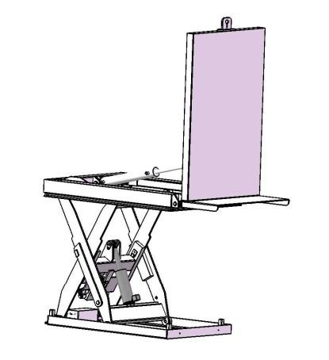
5
1
4
6
3
2

